The Golden Girl
Once upon a time there was a man and a woman. They had a daughter as pretty as a flower. Whoever saw her could not take his eyes from her. They lived you conscientiously and happily, but it was not written it to continue for a long time - the mother became ill with a serious illness and soon died. The man was alone with the girl. It was difficult for him to take care of everything, and his neighbours advised him to marry again. Soon he brought his new wife at home. The stepmother also had a daughter but she came to hate her stepdaughter so much that she couldn't stand it. She started scolding on her all the time and made her do the hardest job and kept muttering her husband about his daughter. One night the stepmother said:
- I do not want your daughter at home. Get her out of here! Otherwise I'll leave you!
The man got very sad. He loved his girl very much and he did not want to listen his second wife. They started scolding every day. A quarrel today, a quarrel tomorrow. The father got sick of this, he got so bored with such a life and inclined to do what his second wife wanted. The stepmother cooked a loaf of ashes, put it in her husband's bag and escorted him home with the stepdaughter. She ordered him not to return back home with his daughter. The man led the girl to a deserted mountain, overgrown with dense forest. And as soon as he climbed a high peak, he took the loaf out, rolled it down the steep slope and told his girl to bring it for lunch. When she returned, his father was gone. She started seeking him. She cried and cried, cried and cried, wandering through the wilderness until it got dark. Suddenly, she saw a small house in the middle of a glade. She heard a voice coming from its window.
- Who's crying? Are you a boy or a girl? If you are a boy - go way, if you are a girl - come to me!
A weird old woman lived in the forest cottage. Her gray-green hair was very sparse, but long and the wind blew it on all sides, so it looked like a web. Her nose was sharp, her nails - long and curved, and there was an owl sitting on her shoulder. The forest witch gave her a shelter and fed the poor little girl.
The little girl got up very early on the next morning, even before the witch wakes up, and cleaned the house. When the old woman woke up, she washed her face, took the owl and went out to do her job in the forest. Before that, she had instructed the girl to feed her animals - all kinds of snakes and lizards.
-Don't be afraid of my pets!, she said. - They don't bite.
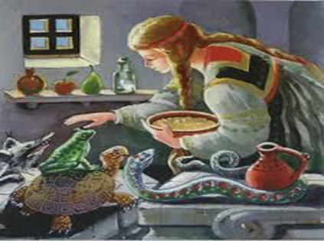
The girl grilled some bran, left it to cool down and fed the snakes and lizards. Then she untied the beads from her necklace and tied a piece of it on each of the pets.
The old witch returned at noon. The reptiles greeted her and began praising her:
- Grandma, grandma the girl put a necklace on my neck! Grandma, the girl put a necklace on me, too!
Then the grandmother replied:
-And Grandma will put a necklace on her neck! Grandma will put a necklace on her neck too!
A river was running near the cottage. As soon as they ate the sweet meal for lunch, the old lady told the girl to go together with her and sit by the river. A few minutes later the Sun warmed the old lady, she yawned and said:
- I may fall asleep. When you see the water flow red, don't wake me up. If you see it change its colour to blue, don't wake me up again. But as soon as the yellow comes, wake me up immediately!
And the old woman fell asleep. At one time the river came red. After that flowed blue. The blue water changed to green, then black. Finally the yellow water came and the girl woke the witch up. She quickly caught her by the hair, plunged her into the river and said:
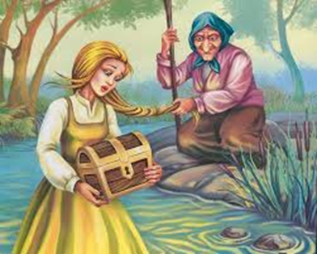
- Hold on, whatever you can my dear! Hold on whatever you can!
The girl grabbing whatever came between her hands, and when the hag pulled her out of the water, she saw she was holding a box. Then the forest witch escorted the girl to the road at the end of the forest, waved goodbye and disappeared. She followed the road and soon returned home. As she stood at the doorstep, her stepmother and father gasped- a golden girl, glowing with an unexpected beauty was standing at the door.
Stretching her hands out, the golden girl gave the box to her father. When he opened it, what a surprise it was- the chest was full of gold. So, the stepmother was full of envy and started muttering her husband to bringing her daughter to the forest to become beautiful and rich.
- If you want it, I'll bring her. - he inclined.
The stepmother rolled up her sleeves, chose the finest white flour and sifted it three times. She kneaded a cake, baked it, wrapped it in a clean cloth, then put it in the bag and gave it to her husband. He put the bag on his shoulder and led his stepdaughter to the peak. When they arrived at the same place, the father rolled the cake and sent the girl to look for it. Then he quickly hid and returned back home. As soon as she reached the cake, the girl started looking for her father, but she did not find him. She started crying, roving through the dense forest. In the evening, she came to the witch’s cottage and heard her voice:
- Who's crying? Are you a boy or a girl? If you are a boy - go way, if you are a girl - come to me!
- I’m a girl, old lady, I’m a girl.
- Then come to me, girl.
And just like the previous time, the witch gave her a shelter and fed the her little guest. But on the morning she didn't get out of the bed before the old woman. The girl waited her to make breakfast for her, and she didn't even move finger to sweep the floor out, as the first girl did. The grandmother was silent and didn’t say anything. She took the owl and went into the forest. Leaving the cottage, when she was by the doorstep, the old woman turned back and told the lazy girl to bake some bran and feed her animals. The witch told her not to be scared of them, because they didn't bite. The girl baked the bran, but did not wait it to cool down but immediately gave it to the snakes and lizards to eat, and they burned their tongues. When witch came back at noon, they greeted her and complained:
- Grandma, the girl scalded me! The the girl scalded me, too!
- And Grandma will scald her too!- said the witch.
After having lunch and the old woman told the girl to go with her by the river. After a while the witch dozed off:
- I got tired. I will take a little nap. You have to look at the river –when it comes red, don't wake me. If you see it come green, don't wake me up again! Don't wake me up when you see the water flow white. If it turns yellow, don't wake me up, but if you see it black, then wake me up!
The old one fell asleep and the girl saw that the river had become red. The red water ran out and the green came. After it flowed white. Then white changed to yellow as gold. The girl liked the yellow water and dipped her little finger into it. The finger got golden. After the golden water flowed black. Then the girl woke the witch up, she got up, grabbed her by the hair and immersed her in the black water. She shauted:
- Hold on whatever you can! Hold on whatever you can!
The girl grabbed whatever she got. The old woman pulled her out of the water. The girl was holding a little chest in her hands. Then the hag escorted the little guest to the end of the forest and let her go. As soon as the girl got back home, her mother reconciled - her daughter was as black as a devil, and when they opened the chest, it was full of frogs, snakes and lizards that crawled out of it.
- What did you do to my daughter? - Shouted the evil wife to her husband.
- - Oh! He said. - I left the girl on the same pace I left the other one. What I did with your girl is what I did with the other one. But where did they go, what they did and what happened – I know as much as you do.
Soon The king's son heard about the golden girl who was as beautiful as no other. He wanted the girl for a wife and sent his representatives to ask the girl to marry him. But the stepmother hid the golden girl under a bath tray. Then dressed her own daughter in a white dress and told her only to show her gold finger under the veil so that people would think she was the golden bride. King’s people took the bride and aheaded back to the castle when the rooster stopped moaning in the dumps, clapped its wings, landed on the fence and started boiling.
- Kukuriguuu! The Gold girl is hidden under the bath tray, the black girl is riding the horse!
- The wedding guests looked at each other, astonished, and when they understood nothing, kept riding. The rooster sang again:
- Kukuriguuu! The Gold girl is hidden under the bath tray, the black girl is riding the horse!
- The wedding guests stopped, but the black bride kicked the horse, and it started walking again.
- Kukuriguuu! The Gold girl is hidden under the bath tray, the black girl is riding the horse!- shouted the cock again.
- This job is not clean! - the wedding guests decided. - Let us see whom we bring to the king's son!
They raised the bride's veil and what to see – a black girl as ugly as a devil. They returned her back to her liar mother and found the golden girl hidden under the bath tray. And when they brought the golden girl to the king's son, the whole palace started glowing with her beauty. They married and lived happily ever after.

THE END

THE GOLDEN GIRL
(Bulgarian fairy tale)
